How to transfer your Flight plans (FPL) to a word document

The following instructions explain how to submit a draft flight plan to have its content checked. It is important that you follow these instructions and don’t actually file the flight plan as if you do it will automatically notify all the airfields on your plan and may result in overdue action being initiated.

Log on to your AFPEx Account.
Open the flight plan form.

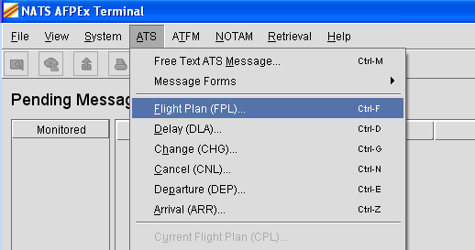

Type in the FPL you would like to check, please fill in all the fields and ensure that there are no error messages.

Change out of ‘Form View’ by clicking on the ‘VIEW’ drop down on the tool bar and then on the ‘Form Mode’ option.

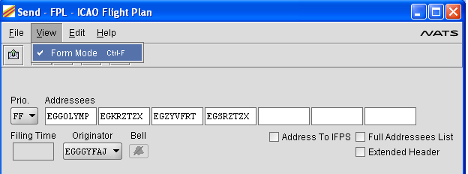

This will change the view to a text only view as below

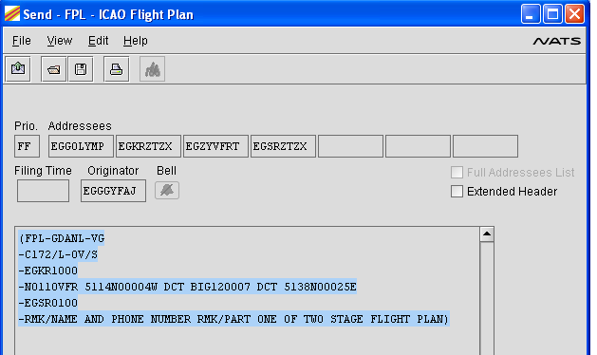

Highlight the flight plan part of the message (the addressing will not be checked by ATLAS control) and press the Ctrl and C buttons simultaneously to copy the text.

Open a word processor application (we have used Microsoft Word) and paste the copied text into a new document.

Repeat the process for all flight plans you wish to have checked then email the (Word) document to olympicsairspace@caa.co.uk

