Visiting Pilots SANDTOFT Airfield

Airfield Information Sandtoft EGCF
Sandtoft Airfield
Belton
Doncaster
DN9 1PN
Tel. 01427 872 034
Fax. 01427 875 670
Email: sandtoftairfield@aol.com
office hours 09:00-18:00
Please PPR on our new Phone number. Your Pooley’s Contact number will be out of Date.
Tel: 01427 872 034
Sandtoft Aerodrome lies in Class "D" with its own ATZ, and Air-Ground Radio, Freq 130.425
Runways available 23/05, Tarmac, Length 886m, Width 18m.
Elevation AMSL 11ft/3m.
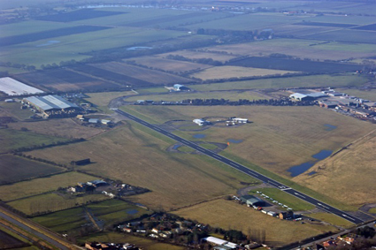
The joining procedure is an overhead join at 1500ft QFE with a circuit height of 1000ft QFE.
It is recommended that you talk to Doncaster Freq 126.225 as you approach and depart the ATZ and to either remain clear of the Doncaster airspace or request clearance (above 1500ft).
The Circuit Pattern is RH for Rwy 23 and LH for Rwy 05.
Rwy 23 is displaced.
Please be considerate to the local residents and avoid flying directly overhead built up areas.

